Assignment 17

Q1. WAJP to print pattern
*
* *
* * *
* * * *
* * * * *
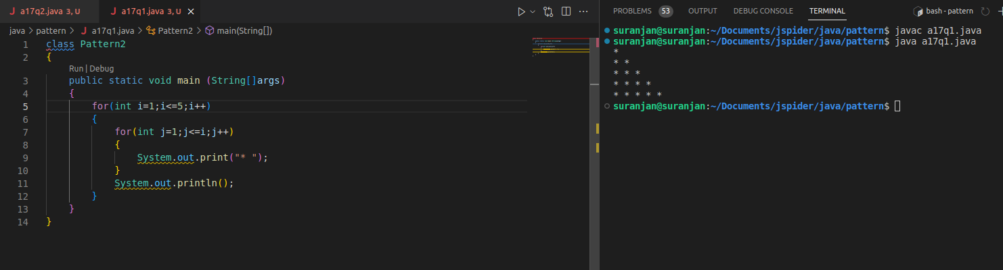

Q2. WAJP to print pattern
a
b c
d e f
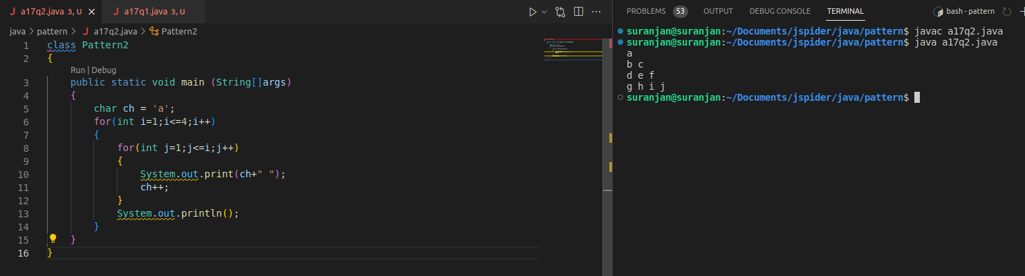
g h i j

